Name: Pratik Jasani

Course: EN60.645

**Artificial Neural Network Self Check**

**1. Draw a linear regression function of 4 variables (4 x’s) and a single output value (y) as a graph. Each** **x_i will be an input variable. Each edge will have a weight theta_i. You can think of the dot product of the x’s and theta’s as z and the output function as y = z. Don’t forget the “bias” term.**



**2. Draw the same as above but for a logistic function. What’s different?**

Activation function(F) will be different



**3. One of the downsides to logistic regression is that we can only make binary classifications. One way of getting around this is to make N logistic regressions, separating the training data into “1” and “not 1”, “2 and not 2”, etc for each of the N possibilities. You then use these N logistic regressions together and assign y to the value from the logistic regression with the largest value. Assuming 4 X’s and N=3, draw this network.**

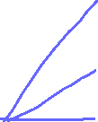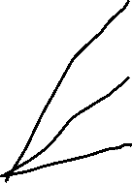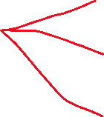

Input layer

Hidden layer

Output layer

**4. Given the following neural network with logistic “activation” functions, calculate the output of the network (Calculate all the “?”)**

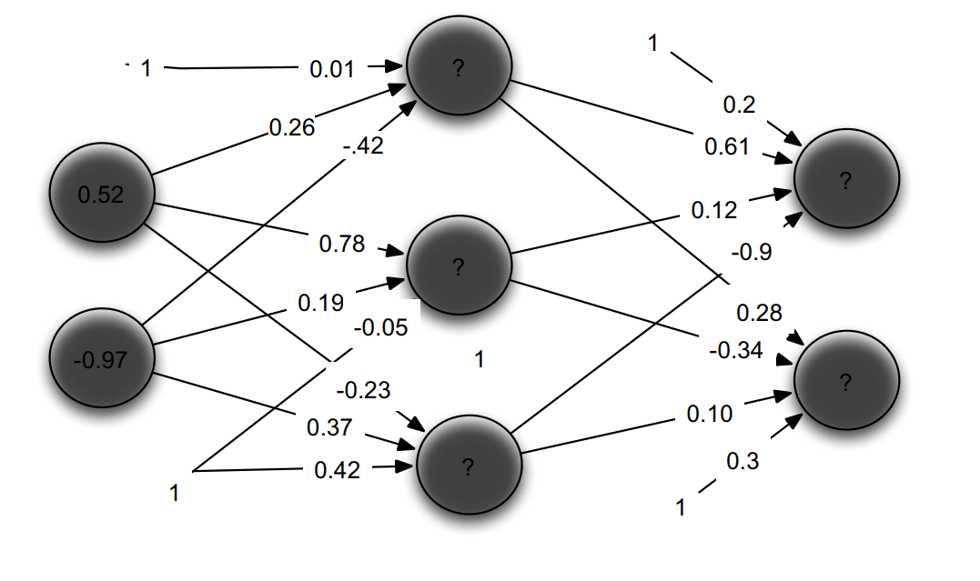

**Equations:**

Z =

Activation function F =

|  |  |  |
| --- | --- | --- |
| **var** | **Z** |  |
| **H1** | 0.01*1 + 0.26*0.52 + -0.42 * -0.97 = 0.5526 | 0.6347 |
| **H2** | -.05*1 + 0.75*0.52 + 0.19 * -0.97 = 0.1557 | 0.5388 |
| **H3** | 1*0.42 + 0.52*-0.23 + 0.37 * -0.97 = -0.0585 | 0.4854 |
| **O1** | 1*0.2 + 0.61*0.6347 + 0.5388*0.12 + 0.4854*-0.9 = 0.214963 | 0.5535 |
| **O2** | 1*0.3 + 0.10*0.4854 + -0.34*0.5388 + 0.28*0.6347 = 0.343064 | 0.5849 |

**Backpropagation**

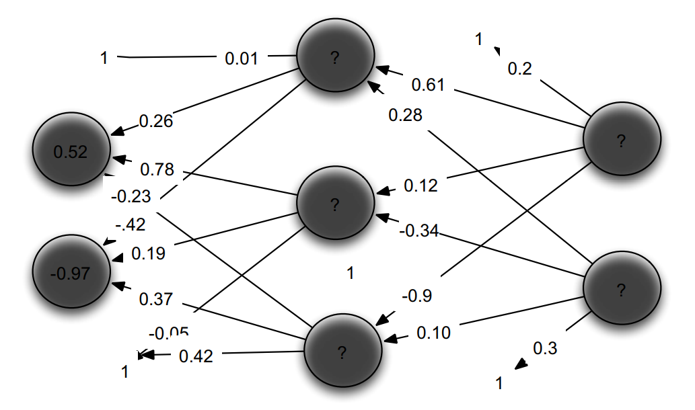

, error for output layer

, weight between the hidden layer and the output layer.

, errors between the hidden layers

, weights between he hidden layers and input layers

, learning rate

|  |  |  |  |  |
| --- | --- | --- | --- | --- |
| **var** |  |  | (Between out and hidden layer) |  |
| **H1** | 0.6347 |  | 0.61 +0.1*-0.137*0.61  = 0.601  0.28 + 0.1 * [0.101*0.28] =0.28 | 0.6347(1-0.6347)*  [-0.137*0.61 + 0.101*0.28] = -0.0128 |
| **H2** | 0.5388 |  | 0.12 + 0.1*[-0.137*0.12] =  0.118  -0.34 = 0.1*[0.101*-0.34]=  -0.343 | 0.5388(1-0.5388)* [-0.137*0.12 + 0.101*-0.34] = -0.0126 |
| **H3** | 0.4854 |  | -0.9 + 0.1*[-0.137*-0.9]  =-0.8876  0.10 + 0.1 *[0.101*0.10]  =0.101 | 0.4854(1-0.4854)* [-0.137*-0.9 + 0.101*0.10]  = 0.0333 |
| **bias** |  |  | 0.2 + 0.1 *[-0.137*0.2]  = 0.197  0.3 + 0.1 *[-0.101*0.3]  = 0.297 |  |
| **O1** | 0.5535 | 0.5535*(1-0.5535)*(0 - 0.5535) = -0.137 |  |  |
| **O2** | 0.5849 | 0.5849*(1-0.5849)*(1 - 0.5849) = 0.101 |  |  |